UC 5 System shall handle loan logic (eligibility, interest, and repayment schedule).

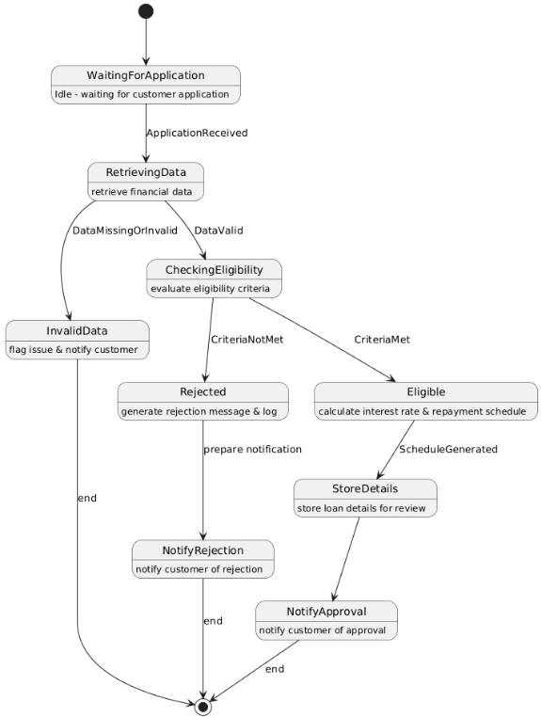

UC_6 Bank employee shall manage and approve/reject customer loan applications

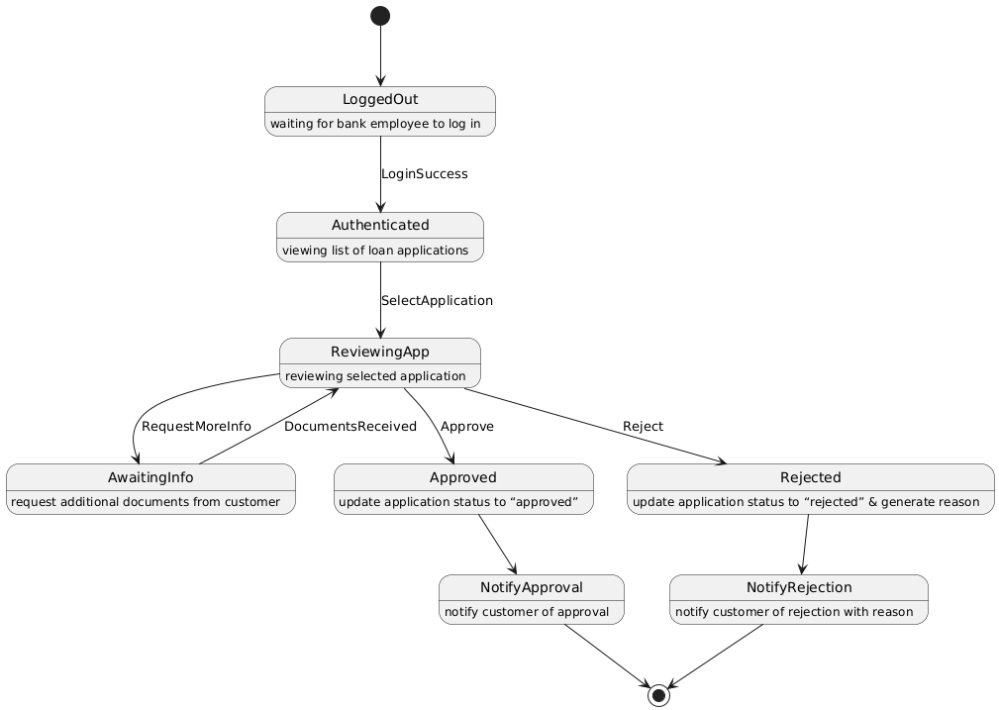

UC_7 Customer shall be able to request a checkbook

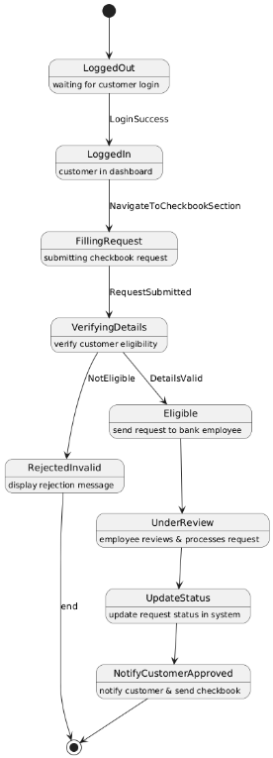

UC_8 Bank employee shall be able to approve or reject account creation requests

